15.75: a) The fundamental has nodes only at the ends, 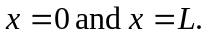 b) For the second harmonic, the wavelength is the length of the string, and the nodes are at 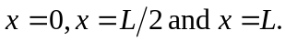

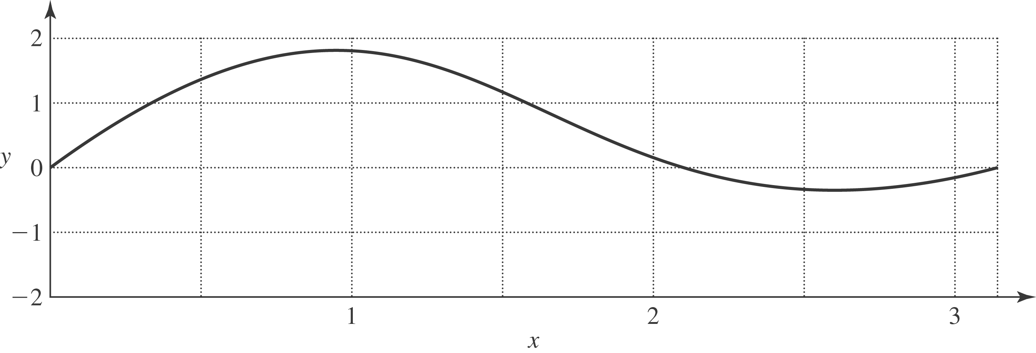

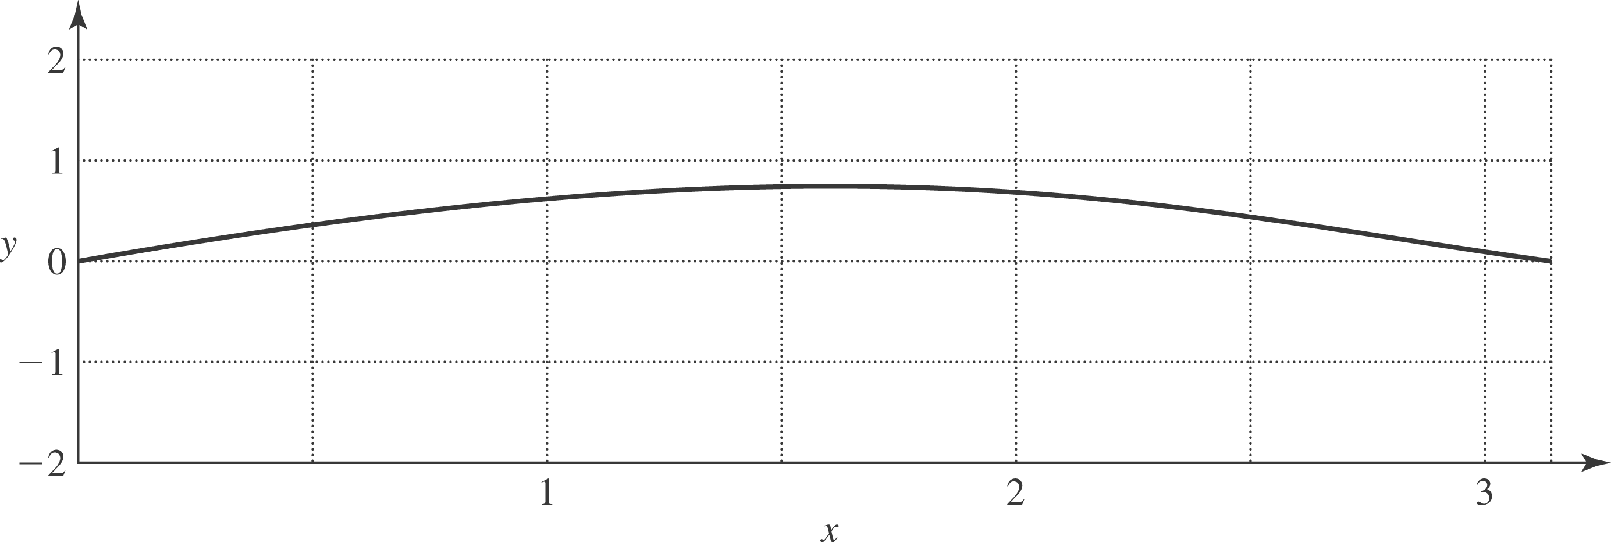
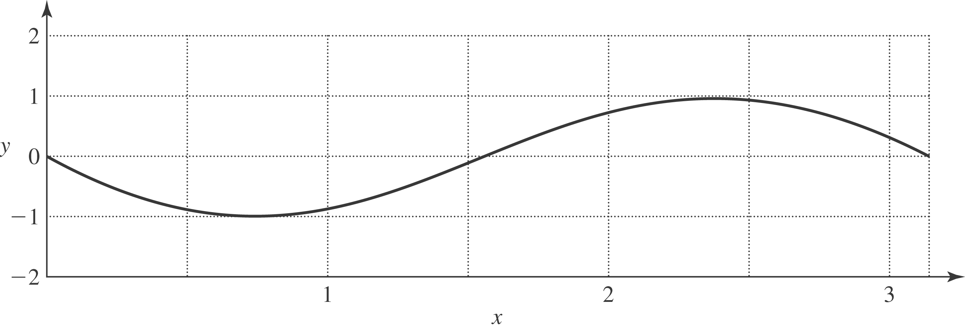
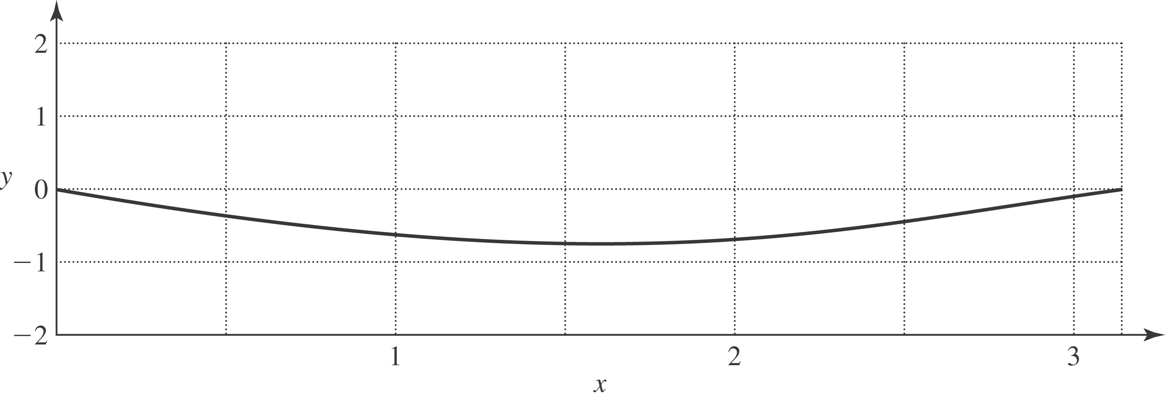
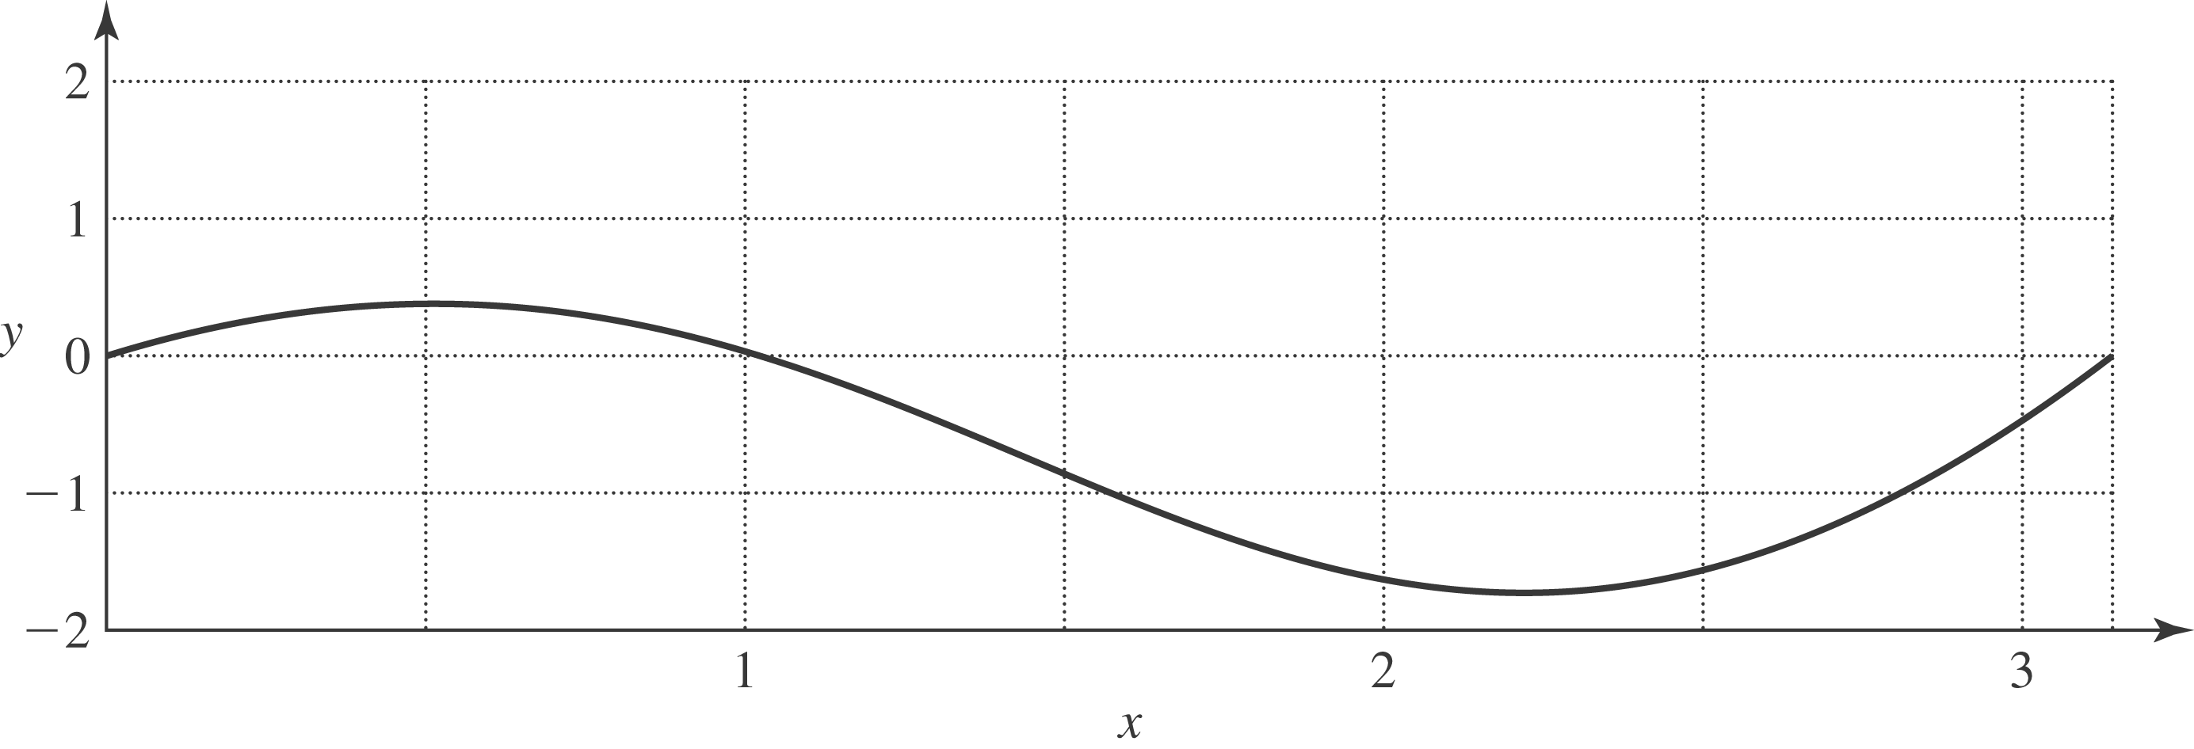

d) No; no part of the string except for 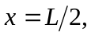 oscillates with a single frequency.

